Library Management System

Submitted By

Student Name | Student ID
Md. Raduan Ahamed | 0242220005101839
Rawnok Jahan Riddi | 0242220005101830
Wahid Tawsif Somoy | 0242220005101838

MINI LAB PROJECT REPORT
This Report Presented in Partial Fulfillment of the course CSE222: Object Oriented Programming II Lab in the Computer Science and Engineering Department



DAFFODIL INTERNATIONAL UNIVERSITY
Dhaka, Bangladesh
December 11, 2024

DECLARATION
We hereby declare that this lab project has been done by us under the supervision of Ms. Nasima Islam Bithi, Lecturer, Department of Computer Science and Engineering, Daffodil International University. We also declare that neither this project nor any part of this project has been submitted elsewhere as lab projects.

Submitted To:

Ms. Nasima Islam Bithi
Lecturer
Department of Computer Science and Engineering
Daffodil International University

Submitted by

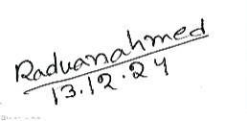  Name: Md. Raduan Ahamed  ID: 0242220005101839  Dept. of CSE, DIU |   Name: Rawnok Jahan Riddi  ID: 0242220005101830  Dept. of CSE, DIU
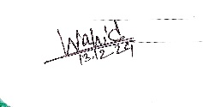

Name: Wahid Tawsif Somoy
ID: 0242220005101838
Dept. of CSE, DIU

COURSE & PROGRAM OUTCOME

The following course have course outcomes as following:.

Table 1: Course Outcome Statements
CO’s | Statements
CO1 | Define and Relate classes, objects, members of the class, and relationships among  them needed for solving specific problems
CO2 | Formulate knowledge of object-oriented programming and Java in problem solving
CO3 | Analyze Unified Modeling Language (UML) models to Present a specific problem
CO4 | Develop solutions for real-world complex problems applying OOP concepts while  evaluating their effectiveness based on industry standards.

Table 2: Mapping of CO, PO, Blooms, KP and CEP
CO | PO | Blooms | KP | CEP
CO1 | PO1 | C1, C2 | KP3 | EP1, EP3
CO2 | PO2 | C2 | KP3 | EP1, EP3
CO3 | PO3 | C4, A1 | KP3 | EP1, EP2
CO4 | PO3 | C3, C6, A3,  P3 | KP4 | EP1, EP3

The mapping justification of this table is provided in section 4.3.1, 4.3.2 and 4.3.3.

Table of Contents

Declaration i
Course & Program Outcome ii
- Introduction 1
  - Introduction 1
  - Motivation 1
  - Objectives 1
  - Feasibility Study 1
  - Gap Analysis 1
  - Project Outcome 1
- Proposed Methodology/Architecture 2
  - Requirement Analysis & Design Specification 2
    - Overview 2
    - Proposed Methodology/ System Design 2
    - UI Design 2
  - Overall Project Plan 2
- Implementation and Results 3
  - Implementation 3
  - Performance Analysis 3
  - Results and Discussion 3
- Engineering Standards and Mapping 4
  - Impact on Society, Environment and Sustainability 4
    - Impact on Life 4
    - Impact on Society & Environment 4
    - Ethical Aspects 4
    - Sustainability Plan 4
  - Project Management and Team Work 4
  - Complex Engineering Problem 4
    - Mapping of Program Outcome 4

Table of Contents Table of Contents

- Conclusion 6
  - Summary 6
  - Limitation 6
  - Future Work 6
References 6

Chapter 1

Introduction
This chapter provides an overview of the project background and problem statement..

Introduction

The Library Management System (LMS) automates library operations such as book management, member tracking, borrowing, and returning. It simplifies tasks, improves efficiency, and reduces errors compared to traditional manual methods.

Motivation

Libraries face challenges in managing books and members manually, leading to inefficiency and errors. The motivation for this project was to streamline library operations, enhance user experience, and reduce administrative workload by automating processes using modern technology.

Objectives

- Automate library tasks like book borrowing and returning.
- Track book availability in real-time.
- Manage members and their borrowed books.
- Provide search and sort options for books.
- Implement secure user authentication for staff and members.

Feasibility Study

Feasibility Study | Case Study: Library Management System
Technical Feasibility | Built using Python and object-oriented programming, ensuring scalability and ease of use.
Operational Feasibility | Simple and user-friendly interface, requiring minimal technical knowledge.
Financial Feasibility | No major financial costs since Python is an open-source language, and only development time is required.
Time Feasibility | The project can be completed within the given timeline, with room for future upgrades.

Gap Analysis

Current System | Proposed System
Manual record keeping | Automated data management
Limited book search | Advanced search and sort
No borrowing tracking | Tracks borrowed and returned books
No user authentication | Secure login for members and staff

Project Outcome
The Library Management System successfully automates library tasks, improves efficiency, and enhances the user experience. It allows easy book tracking, borrowing, returning, and member management. The system provides a reliable, scalable solution for libraries of all sizes.

Chapter 2

Proposed Methodology/Architecture

The Proposed Methodology/Architecture chapter will outline the system design, including the technologies used, database structure, and the workflow for implementing the Library Management System.

Requirement Analysis & Design Specification

Overview

The following steps outline the project approach:

1. Idea Selection
The Library Management System was developed to address the challenges of manual book tracking and member management, aiming to improve efficiency, accuracy, and user experience through automation.

2. System Design (Class Design)
The system uses object-oriented design with the following classes:
- LibraryItem (Abstract Class): Base for all library items.
- Book: Manages book details like title, author, and copies.
- Member: Manages member data and borrowed books.
- Library: Manages books and members, with features like adding, searching, and sorting.
- UserAuth: Handles secure user authentication.

3. Technical Requirements
- Language: Python 3.x
- Libraries: hashlib (password hashing), datetime (date management)
- Platform: Any system with Python
- Storage: In-memory data

4. Implementation Using Python
The system automates book management, member actions (borrowing/returning), and user authentication using Python’s object-oriented features.

5. Testing the System
The system was tested through unit and integration tests to ensure proper functionality and error handling, including book borrowing, returning, and overdue fines.

6. Finalizing the Project
The system was completed, integrated, tested, and is ready for deployment, with potential for future enhancements like database support.

Proposed Methodology/ System Design

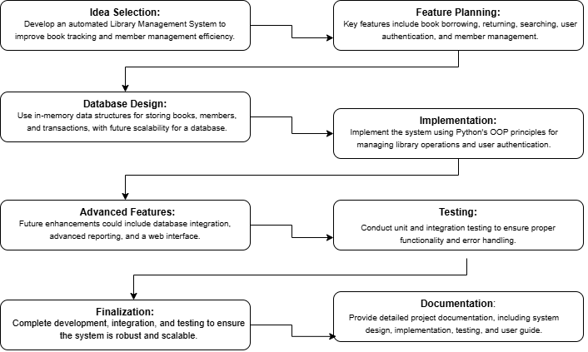

UI Design

Library Management System

UML Diagram
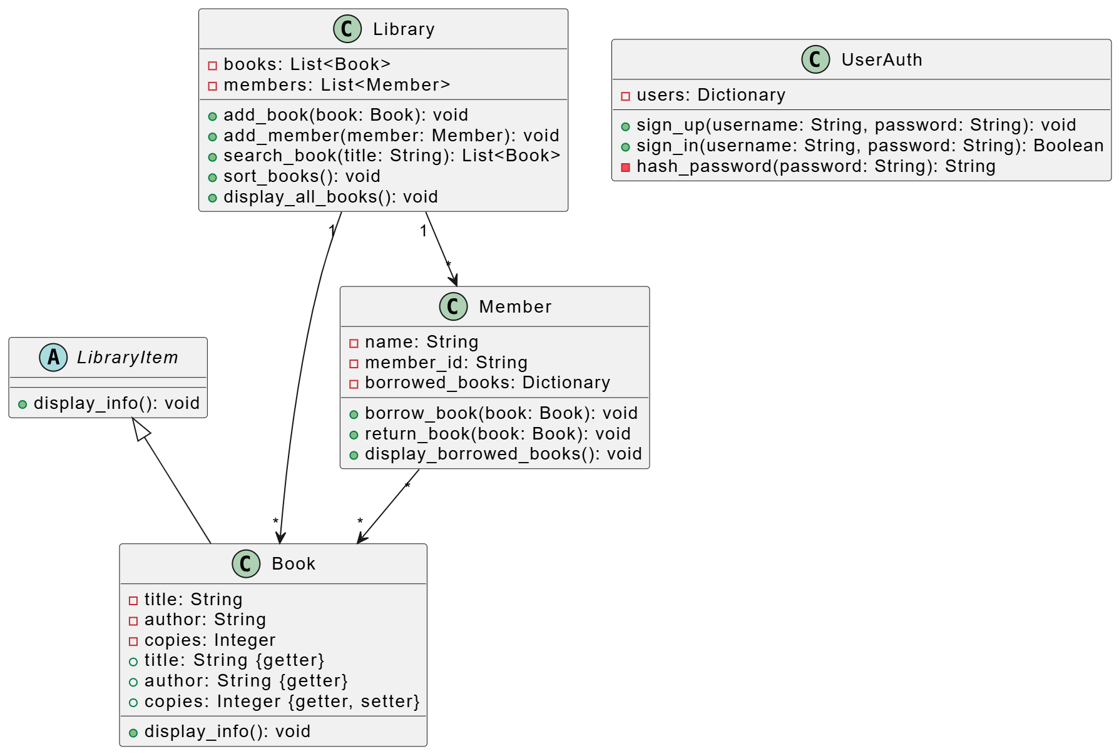

Overall Project Plan

Overall Project Plan
The Library Management System was designed and implemented over a period of 21 days, with distinct phases dedicated to specific activities and milestones.

Phase 1: Ideation and Requirements Gathering (Days 1–4)
- Brainstorming and finalizing the project scope and objectives.
- Researching existing library systems for feature ideas.
- Drafting functional and non-functional requirements.
- Identifying technical tools and frameworks (Python, UML tools).
- Creating a project timeline with task assignments.

Phase 2: Architectural Design and Database Setup (Days 5–8)
- Developing the system architecture and class structure using UML diagrams.
- Designing an ERD (Entity-Relationship Diagram) for the database.
- Translating the ERD into a database schema.
- Defining constraints, primary/foreign keys, and relationships.

Phase 3: Core System Development (Days 9–13)
- Implementing core Python classes (Library, Book, Member, etc.).
- Adding authentication functionality (e.g., UserAuth class).
- Implementing encapsulation, exception handling, and validations.
- Testing individual modules after implementation.
- Iteratively refining code based on feedback.

Phase 4: User Interface and Feature Integration (Days 14–17)
- Creating a user-friendly command-line interface for system interaction.
- Integrating core features like borrowing, returning, searching, and sorting books.
- Adding administrative functionalities (e.g., adding books/members).
- Testing for usability and improving interface flow.

Phase 5: Testing and Optimization (Days 18–19)
- Conducting system-level testing to ensure seamless functionality.
- Testing edge cases and scenarios for robustness (e.g., over-borrowing, invalid inputs).
- Fixing identified bugs and optimizing performance (e.g., faster book searches).
- Running integration tests to ensure all components work harmoniously.

Phase 6: Finalization and Presentation Preparation (Days 20–21)
- Documenting the project workflow, architecture, and implementation details.
- Creating final UML diagrams and other visual aids for the presentation.
- Reviewing the complete project with team members.
- Preparing and rehearsing the project presentation.

Chapter 3

Implementation and Results

This chapter details the implementation and results of the Hospital Management System.

Implementation
The Library Management System was developed in Python using object-oriented principles. Key classes include:
- Book: Manages book details and borrowing/returning logic.
- Member: Manages member actions like borrowing and returning books.
- Library: Manages books and members, with features like adding, searching, and sorting books.
- UserAuth: Handles user authentication via signup and login.

Performance Analysis
- Time Complexity: Searching for books (O(n)), sorting books (O(n log n)), borrowing/returning books (O(1)).
- Space Complexity: O(n) for storing books and members.
- The system is efficient for small to medium-sized libraries but may slow down with larger datasets due to the linear search.

Results and Discussion
Result: The system works as expected, allowing users to sign up, borrow, and return books. Books can be searched, sorted, and displayed, and late fees are correctly applied.
Discussion: The system is effective for small libraries but could be enhanced with faster search algorithms and database integration for scalability. Future improvements include better user authentication and a web interface for accessibility.

Chapter 4

Engineering Standards and Mapping

Every chapter should start with 1-2 sentences on the outline of the chapter.

Impact on Society, Environment and Sustainability

The Library Management System enhances access to resources, reduces paper usage, and lowers the environmental footprint. It is designed for scalability, ensuring long-term sustainability and efficient operation as the library grows.

Impact on Life
The Library Management System improves accessibility to library services, enabling users to manage their books more efficiently through an automated and easy-to-use platform.

Impact on Society & Environment
By digitizing library operations, the system reduces the need for physical paperwork, leading to a reduction in paper usage and overall environmental footprint.

Ethical Aspects
The system ensures user data confidentiality, adhering to ethical standards of privacy and security. It upholds responsible management of personal and borrowed information in compliance with privacy laws.

Sustainability Plan
The system is designed to scale as the library grows, with features that allow easy updates, maintenance, and integration of new functionalities, ensuring long-term usability and sustainability.

Project Management and Team Work
Project Management
The project was managed through clear task distribution, where each team member handled specific aspects like system design, coding, testing, and documentation. Resources were utilized efficiently, with tools like GitHub for version control and communication platforms for collaboration. Progress was monitored through regular meetings, milestone tracking, and updates to ensure timely completion and alignment with project goals. This approach facilitated smooth teamwork and successful project delivery.

Team Work

  - Rawnok Riddi (1830):

Riddi developed the Book, Member, and Library classes, enabling efficient access and management of library data.

  - Raduan Ahamed (1839):

Raduan created the UserAuth class, ensuring system security through authentication and handling exceptions for smooth operations.

  - Wahid Somoy (1838):

Smoy worked on setting up default users, passwords, books, and members to facilitate quick output demonstrations and testing.

Complex Engineering Problem

This project addresses the integration of multiple software components, including user authentication, secure data management, and ensuring scalability. It involves handling large datasets, maintaining system performance as the library grows, and ensuring secure, efficient management of user information and book transactions.

Mapping of Program Outcome
The project aligns with PO1 (applying engineering knowledge) and PO3 (designing complex solutions) by developing a secure, scalable system. It demonstrates the application of software engineering principles to solve practical problems, including secure user authentication, efficient data management, and creating a system that can scale as needed.

Table 4.1: Justification of Program Outcomes
PO’s | Justification
PO1 | Demonstrate a comprehensive understanding of fundamental database management concepts, including the relational data model, normalization techniques, and SQL basics  Design, implement and optimize relational databases, incorporating advanced SQL queries, indexing techniques and query optimization strategies.
PO2 | Design, implement and optimize relational databases, incorporating advanced SQL queries, indexing techniques and query optimization strategies.

    - Complex Problem Solving
The Library Management System addresses engineering problem categories defined by EP1–EP7. The table below maps these categories with their justification.

Chapter 4. Engineering Standards and Mapping 4.3. Complex Engineering Problem
Knowledge profile and rationale thereof.
Table 4.2: Mapping with complex problem solving.
EP1  Dept of Knowledge | EP2  Range of Conflicting Requirements | EP3  Depth of Analysis | EP4  Familiarity of Issues | EP5  Extent of Applicable Codes | EP6  Extent  Of Stakeholder Involvement | EP7  Inter- dependence
The project requires knowledge in software engineering, data management, and system security. | Balancing security, user access, scalability, and system performance. | In-depth analysis of system design to ensure efficiency and security. | Familiarity with common issues in user authentication and database management. | Ensuring compliance with data security and software development standards. | Involvement of users and library staff to ensure system meets their needs. | Interdependence between user authentication, data management, and system scalability.

    - Engineering Activities
This section maps the project's engineering activities with categories EA1–EA5, providing rationale for each activity.

Table 4.3: Mapping with complex engineering activities.

EA1  Range of resources | EA2  Level of Interaction | EA3  Innovation | EA4  Consequences for society and  environment | EA5  Familiarity
Utilizes a variety of resources, including programming languages, frameworks, and databases. | High interaction among team members, as well as with end-users for feedback and improvements. | Innovative approach in integrating user authentication and scalable data management. | Improves accessibility and efficiency in library systems, with minimal environmental impact due to digitalization. | Familiarity with software development practices, security protocols, and system scalability challenges.

Chapter 5

Conclusion

This project demonstrates a functional library management system that integrates core features such as user authentication, secure data management, and efficient library resource handling. The system provides a user-friendly solution for managing library operations securely.

Summary

• The system allows users to borrow, return, and search for books.
• Authentication ensures secure access for users.
• Data is managed efficiently with real-time updates for book availability.

Limitation

• Limited Time Frame: The project was developed within a short timeframe, restricting certain features and optimizations.
• Console-Based Interface: The system currently operates through a text-based interface, which limits user interaction.
• Absence of Persistent Storage: Data is not saved after the program ends, which limits the ability to store long-term user and book information.

Future Work

Persistent Data Storage: Implement a database for storing book and user information to ensure data retention across sessions.

Graphical User Interface (GUI): Develop a more interactive and user-friendly graphical interface to improve accessibility.

Advanced Features: Add features like automatic due date reminders, fine calculations for late returns, and advanced search filters for books.

References

Lutz, M. (2009). Learning Python. United States of America: O’Reilly Media, Inc., 1005 Gravenstein Highway North, Sebastopol, CA 95472.

Evergreen Library System
Open-source ILMS supporting automation, search features, and scalable library operations.
Evergreen ILS

Github Link

